**Shop-Nest Store Dashboard Report**

**Table of Contents:**

* **Introduction**
* **Question Statement**
* **Visualization**
* **Explanation**

**Introduction**

This report provides a comprehensive analysis of the Power BI dashboard created for the Capstone Project. Each section addresses a specific question or task, supported by visualizations and detailed explanations. The aim is to present key insights derived from the data to aid in decision-making processes.

**Question Statement :1**

Identify the rating distribution in the Shop_Nest dataset, showcasing ratings categorized as Excellent, Very Good, Good, Bad, and Very Bad, along with corresponding orders.

**Visualization**

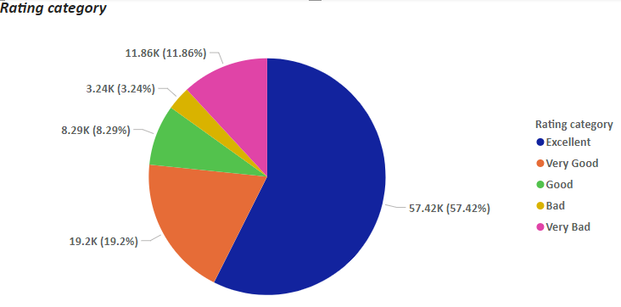

**Explanation**

The Pie chart illustrates the distribution of ratings within the Shop_Nest dataset. Each segment of the chart corresponds to a specific rating category, allowing for a clear visual representation of customer feedback.

Key Insights:

* Excellent (57k of total ratings): This category forms the largest segment, indicating a significant proportion of highly satisfied customers.
* Very Good (19k of total ratings): The second-largest segment, reflecting a strong positive reception.
* Good (8k of total ratings): A moderate portion of customers provided a neutral or satisfactory rating.
* Bad (3k of total ratings): A smaller segment, highlighting areas where improvements may be necessary.
* Very Bad (12k of total ratings): The smallest segment, suggesting relatively few customers had a highly negative experience.

These insights suggest that the overall customer sentiment is positive, with a majority of customers rating their experience as Excellent or Very Good. The smaller proportion of negative ratings indicates potential areas for improvement.

**Question Statement :2**

What are the top 10 and bottom 18 most popular product categories in the ShopNest dataset? Please list them based on the number of orders.

**Visualization**

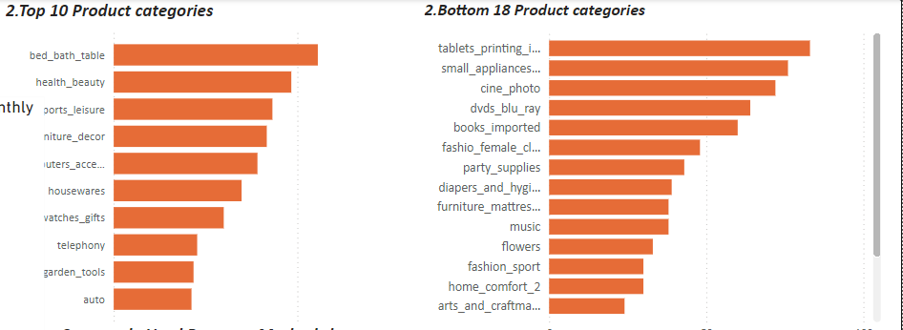

**Explanation**

The Clustered Bar chart explains identifying the products Top 10 and Botton 18 within the Shop Nest dataset.

* Top 10 Products: These are the products that are selling the most or getting the most orders.
* Bottom 18 Products: These are the products that are selling the least or getting the fewest orders.

Key Insights:

1. Best Sellers: The top 10 products are likely bringing in most of the sales or orders. These are the items customers prefer.
2. Low Performers: The bottom 18 products aren't doing well. They may need better marketing, changes, or could even be removed from the lineup if they continue to underperform.
3. Focus Areas: It might be wise to focus on promoting the top products further since they already have customer interest.

**Question Statement :3**

List the total number of active sellers by yearly and monthly

**Visualization**

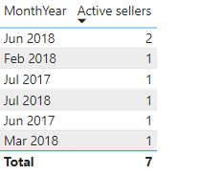

**Explanation**

The table shows the number of active sellers for different months and years.

* Each row represents a specific month and year (like "Jun 2018").
* The second column shows how many sellers were active during that month.
* For example, in June 2018, there were 2 active sellers.
* The total at the bottom adds up the active sellers across all listed months, giving a total of 7 active sellers.

**Question Statement :4**

Which payment methods are most commonly used by ShopNest customers.

**Visualization**

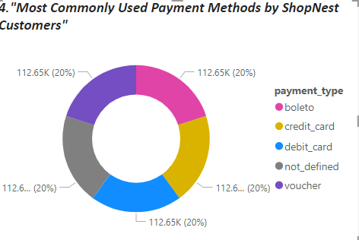

**Explanation**

The donut chart represents the distribution of different payment methods used by ShopNest customers.

* Each colored segment of the donut chart corresponds to a different payment method (like boleto, credit_card, debit_card, etc.).
* The labels around the chart show the number of times each payment method was used (all are 112.65K, which represents 20% of the total).
* The equal percentage (20%) for each method suggests that customers used all these payment methods evenly.

In summary, ShopNest customers used a variety of payment methods, with each method being equally popular among them.

**Question Statement :5**

Identify the product category. wise profit margin using the formula  
Hint: (Payment value -price + Freight_value)/payment_value*100 (Rounded to two decimal points).

**Visualization**

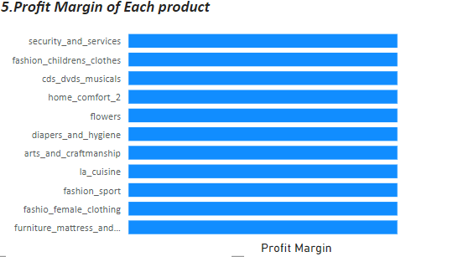

This horizontal bar chart shows the profit margin for different product categories.

* Each bar represents a product category (like security_and_services, fashion_childrens_clothes, etc.).
* The length of the bar indicates the profit margin for that product category.
* All bars appear seems to be of equal length, which suggests that each product category has the slight difference profit margin.
* For better understanding we can analyse the exact profit margin in table view

**Question Statement :6**

Determine the monthly payments made by customers using credit cards.

**Visualization**

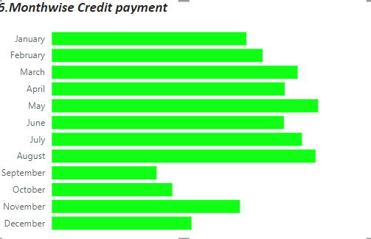

**Explanation**

The bar chart explained the "Monthwise Credit payment." Each bar represents the amount of credit payments made during each month, with the months listed on the left side (January to December).

Key Points:

* Bars Length: The length of each green bar corresponds to the total credit payments made in that particular month. Longer bars indicate higher credit payments, while shorter bars indicate lower payments.
* May and August seem to have the highest credit payments, as these months have the longest bars.
* September has the shortest bar, indicating the lowest credit payments during that month.

This chart helps visualize and compare monthly credit payments at a glance.

**Question Statement :7**

Identify sellers categorized by city, excluding cities starting with the letters S and B.

**Visualization**

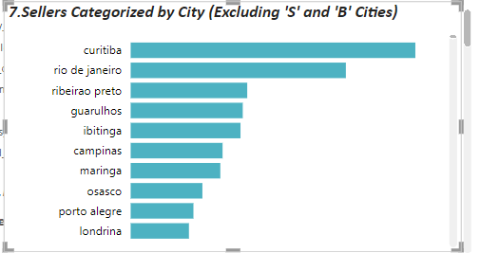

**Explanation**

The Clustered bar chart represents "Sellers Categorized by City (Excluding 'S' and 'B' Cities)." It shows the number of sellers in different cities, with the cities listed on the left.

Key Points:

* Bars Length: The length of each bar represents the number of sellers in that specific city. Longer bars indicate more sellers, while shorter bars indicate fewer sellers.
* Cities Excluded: Cities that start with the letters 'S' and 'B' have been excluded from this chart.
* This chart helps visualize the distribution of sellers across different cities, making it easy to compare which cities have more or fewer sellers.
* In **report view** we can view total sellers across different cities.

**Question Statement:8**

Create a dynamic visual that compares the number of delayed orders to the number of orders received earlier for each month. Utilize the drill through the cross-report feature to provide a detailed analysis of late and on-time deliveries.

**Visualization**

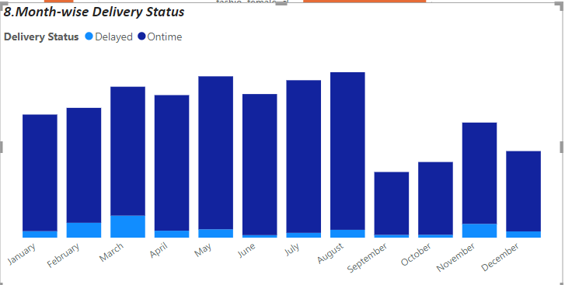

**Explanation**

The bar chart titled "Month-wise Delivery Status," which displays the delivery status (either Delayed or Ontime) of orders for each month.

* Bars: Each bar shows the total number of deliveries in a month, with the dark blue portion showing the on-time deliveries and the light blue portion showing the delayed deliveries.
* March, May, and December have noticeable portions of delayed deliveries compared to other months, as shown by the light blue segments.
* August has the tallest bar, indicating the highest number of deliveries, with most being on time.
* September has the shortest bar, indicating fewer deliveries, but a very small portion was delayed.

This chart helps to quickly assess how well deliveries were managed each month, by showing the proportion of on-time versus delayed deliveries.